## Silica Determination in Wheat Leaves with ATR-FTIR and Chemometrics

## Abstract

Important crops such as wheat, barley, and rice accumulate silicon (Si), which contributes to the response of stress-relief mechanisms for environmental events such as drought and pathogen attack. Because of the importance of these crops, understanding the relationship between this element and plant science is the focus of numerous scientific efforts. Si quantification is a challenging and costly task, and destructive wet chemistry methods are commonly used. This study presents a non-destructive method for silicon determination in wheat leaves using attenuated total reflection infrared spectroscopy (ATR-FTIR) and chemometrics. Wheat (*Triticum aestivum*) was grown in a greenhouse under high (1.5 mM Na2SiO3) and low-Si supply (0.24 mM Si) conditions for 90 days; a third group was grown with low-Si supply for 85 days and five days with high-Si supply. The Si concentrations in leaves, roots, stem, pods, and inflorescence bracts were analyzed. The Si was quantified by inductively coupled plasma-optical emission spectroscopy elemental analysis (ICP-OES).

Principal component analysis (PCA) was performed to determine if the sample preparation methodology allowed identifying different plant tissues and the Si-supply treatments using baseline-corrected ATR-FTIR spectra. PCA plots distinguished leaves and roots from a group of stems, pots, and inflorescence bracts; in leaves, the three Si-supply treatmenst were distinguished.

The leaf spectra were used to construct a series of models based on ordinary least squares regression. A genetic algorithm selected varying sets of wave numbers. The models showed a powerful correlation with the Si content determined by ICP-OES. The performance in prediction of each model was assessed using repeated k-fold cross-validation, showing a maximum error of prediction (RMSEP) of 0.1% wt. with minimum model complexity of four selected variables. However, a strong dependence on the matrix was noted when compared with other plant tissues.

## Introduction

The presence of silicon (Si) in plants contributes to the response of stress-relief mechanisms for environmental events such as drought and pathogen attack. Because of the importance of crops such as wheat, barley, rice, and other grasses that accumulate Si, understanding the relationship between this element and plant polymers has been the focus of numerous scientific efforts. Silicon is a soil constituent; therefore, plants invariably grow in Si-rich-environments (Epstein, 1994). In soil, Si is available in the form of silicic acid solutions. Some plants accumulate enough silicic acid that Si precipitates as silica, e.g., phytoliths. The accumulation occurs mainly in root endodermis, epidermal cells of both leaf and inflorescence bracts (Kumar et al., 2017), as well as awns and leaf macrohairs (Głazowska et al., 2018).

Si determination methods for plant material are described in the literature. They include inductively coupled plasma with mass spectrometry (ICP-MS) and optical emission spectroscopy (ICP-OES). These methods have several advantages, such as quantifying most elements in the periodic table in practically all sample types (Laursen et al., 2009). However, the method requires microwaved or autoclaved digestion samples in strong acids. So, the methods are costly, require a lot of manual work and time, and use considerable amounts of solvents. Millions of plant samples can be produced, but only a few can be fully characterized. When mostly one element is of interest, the effort seemed more futile. Fourier transform infrared (FTIR) spectroscopy in the mid-infrared region is highly sensitive to chemical components present in organic material. Together with chemometric tools, FTIR provides an efficient tool for the qualitative and quantitative characterization of silicon in complex environmental matrices. (Melucci et al., 2019; Vogel et al., 2008).

In 1999, an experiment to study silicon absorption by wheat was set up (Rafi and Epstein, 1999). Four wheat plants were grown in a 100 ml tank containing 0.5 mM Na2SiO3. The plants absorbed Si until it was depleted in ca. 80 days. Another set of plants was grown in a Si-free environment with the same conditions; as there were no stressors, the Si-free plants grew normally. On day 80, some of the mature Si-free plants were transferred into a solution containing 0.5 mM Na2SiO3. The mature plants absorbed the same amount of Si in three days, as did plants grown in solutions to which Si had been added during their whole life. The 1999 experiment was set up both in a greenhouse and in a controlled growing chamber yielding the same result: plants deprived of Si avidly absorbed the element at maturity.

In 2017, we set up a similar experiment that included similar treatments: (1) A group of wheat plants was grown for 90 days in a solution containing 1.5 mM Na2SiO3; this group was called Si+; (2) a group (Si++) grown without Si until day 85, then 1.5 mM Na2SiO3 added to the tank; (3) a control group without silicon (Si-). The plant cell walls of different tissues were extensively extracted to reduce heterogeneity, non–cell wall components, and non-cell bound silica.

Two interesting things were observed when we analyzed the data with chemometrics. (1) Using Principal Component Analysis (PCA) of the ATR-FTIR spectra, it was possible to distinguish samples from different parts of the plant, and in the case of the leaves, the groups could be distinguished according to the silicon supply group. (2) We could develop a fast and non-invasive method for silicon quantification using the ATR-FTIR spectra of the greenhouse-grown wheat leaves.

## Material and Methods

1. Plant growth and sampling

**Nutrient solution**: The nutrient solution was prepared according to a Standard Operational Procedure of the greenhouse at the University of Copenhagen in Rolighedsvej. In this procedure, commercial fertilizers are mixed in three different 250 L tanks with the formulations in Table 1. Then, an automatized pumping system mixes different ratios of the solutions in the tanks. The solutions are mixed with ozonized water which contained Si levels of 0.24±0.08 mM SiO2. For the experiment, ca.150 L of the nutrient solution was used weekly. The Si content was measured on every occasion with the method described below. Then, 1.5 mM Na2SiO3 was added to 50 or 100 L of solution (depending on the timeline) from a 30 mM stock solution diluted in dm-water, while the same amount of dm-water was added to the controls. The measured Si content after dilution was 1.5±0.16 mM. At the end of each week, another Si sampling was performed, and the concentrations were always above 0.6 mM, which ensures Si surplus. pH was adjusted to 6 using HCl or NaOH solutions.

Table 1. Nutrient solution



**Silicon measurements:** Dissolved silica was measured by heteropoly blue method using the Hach protocol 8186 and a DR/1900 spectrophotometer (HACH Company, Loveland, USA) as described by the manufacturer. A Si standard solution of 1.0 mg/L also from Hach (cat 110649) was used for calibration. Polypropylene volumetric flasks were used for dilution of samples to avoid Si contamination.

**Plant production:** Wheat seeds (JB Asano) were surface sterilized as follows. The seeds were immersed in 2.7% sodium hypochlorite solution (v/v) and a drop of Tween 80 for 30 minutes with constant stirring, then rinsed with MilliQ water five times (10 min each). The seeds were vernalized in the dark at 5°C in MilliQ water for four days. After that, the seeds were placed in Si-free oasis horticubes (Smithers-Oasis, Kent, Ohio). The cubes were soaked in 1/10 strength nutrient solution (adjusted to pH 5.5), and excess water drained. Each seed was placed directly into a wet cube. Once seeds started rooted and grew actively (4-7 days), they were left in a cold room for a vernalization period of 50 days.

After vernalization, the plants were cultured using the RainForest 72 aeroponic culture system (GHE, Fleurance, France), and placed in a greenhouse, mean temperature 20°C, under 9 h/15 h light (80–100 μE m−2 s−1)/dark regime. (Figure 1).

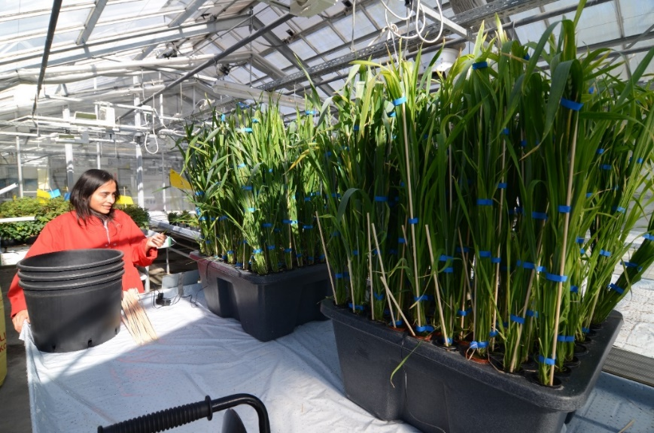

Figure 1. RainForest 72 aeroponic culture system (GHE, Fleurance, France) used to produce wheat plants in a greenhouse.

**Sampling:** Periodically, sample plants were harvested and divided between roots, pods, leaves, flag leaves, and inflorescence bracts according to the day of harvesting (Table 2).

Table 2. Plant parts harvested

|  |  |  |  |  |
| --- | --- | --- | --- | --- |
| **Plant Part** | **Days** | | | |
| **60** | **70** | **80** | **90** |
| Stem | X | X | X | X |
| Pods |  |  |  | X |
| Flag leaves |  |  |  | X |
| Leaves | X | X | X | X |
| Inflorescences | X | X | X | X |
| Roots | X | X | X | X |
| Grain |  |  |  | X |

The biomass was dried, ground, and extracted, using the option of *extensive solvent extraction method* published in (Mansfield et al., 2012). Briefly, the plant materias was air-dry until for 2–3 d at ambient temperature. Then, it was grinded in the mixing mill Retsch mm 400 with a frequency of 30 rpm for 2-3 minutes. Around 200–1,500 mg of plant material was addedto a 50-ml conical centrifuge tube. 30 ml of 50 mM NaCl was added vortexed. The solution was placed in a 4 °C refrigerator overnight. After centrifugation for 10 min at 2,800g at 1 °C, the solvent was removed by decanting. 40 ml of 80% ethanol was added. The samples was sonicated for 20 min, the mixture was centrifuge at 2,800g at 1 °C for 10 mimites. This step was repeated sucessively with 80% ethanol two additional times, 40 ml of 100% acetone, 40 ml of CHCl3/methanol (1:1), and 40 ml of 100% acetone. The material was freeze-dryed overnight, before the other analyzes were performed.

1. Chemical and chemometric analsys

**ATR-FTIR**: The spectra were recorded using a Thermo Fischer Scientific Nicolet 6700 FTIR spectrometer (Thermo Fischer Scientific, Waltham, MA, USA) equipped with a Goldengate ATR accessory (Specac Ltd, Orpington, Kent, UK). Spectra from 4000 to 600 cm−1 were obtained with a 4 cm−1 resolution, 200 background scans, and 100 scans for each sample spectrum. The average of the three spectra was calculated for each sample.

The ATR-FTIR spectra were analyzed in R (R core team, 2021, Version 4.0.5). The package hyperspec was used to perform baseline correction via the rubberband method (Hovde 2010, Beleites 2020). The package prospectr was used for spectra derivatization and smoothing (Wentzell and Brown, 2000), via savitzkyGolay function (Savitzky and Golay, 1964), and the package factoextra to perform hierarchical clustering.

Data analysis. The multivariate statistical method, PLS, was used to create calibration models to relate the spectra obtained to the concentrations of the Poly-P spiked sediment samples. The statistical analysis was performed using the Unscrambler™ X, Version 10.0.1 Camo ASA computer software package.

PLS models were validated by selection of the full cross-validation option available in the software. The regression coefficients (R2) and the root mean square error of prediction (RMSEP) for the PLS regression models were used as calibration and prediction quality measurements or “degree of good fitness”.

The RMSEP is the standard deviation of the errors (the differences between the measured ŷi and predicted values yi). The RMSEP is calculated from a leave-out-one-cross-validation analysis selected in the software (equation below), where n is the number of prediction samples:

|  |  |  |
| --- | --- | --- |
| ugraphic, filename = c2an35289c-t1.gif | | |
|  |  |  |

The size of the regression coefficients gives an indication of which variables have an important impact on the response variables (i.e. Poly-P concentration).

**Elemental analysis:** Multi-elemental analyses of the solid samples was performed using inductively coupled plasma-optical emission spectroscopy (ICP-OES). A sample (10–50 mg) was mixed with 500–2500 μL 70% HNO3, 250–1000 μL 15% H2O2 and 40–200 μL 49% HF, and then digested in a pressurized microwave oven for 10 minutes with a starting pressure of 40 bar and a temperature of 240°C. After digestion, samples were diluted to a final 3.5% acid concentration with Milli-Q water before measurement on an ICP-OES (Model Optima 5300 DV, PerkinElmer) equipped with a HF-resistant sample introduction kit. For quantification, an external 10-point calibration standard P/N 4400-132565 and P/N 4400-ICP-MSCS (CPI International, Amsterdam) was used. A certified reference material (CRM) NCS 73013 Spinach leaf was analyzed together with the samples to evaluate the accuracy and precision of the analysis.

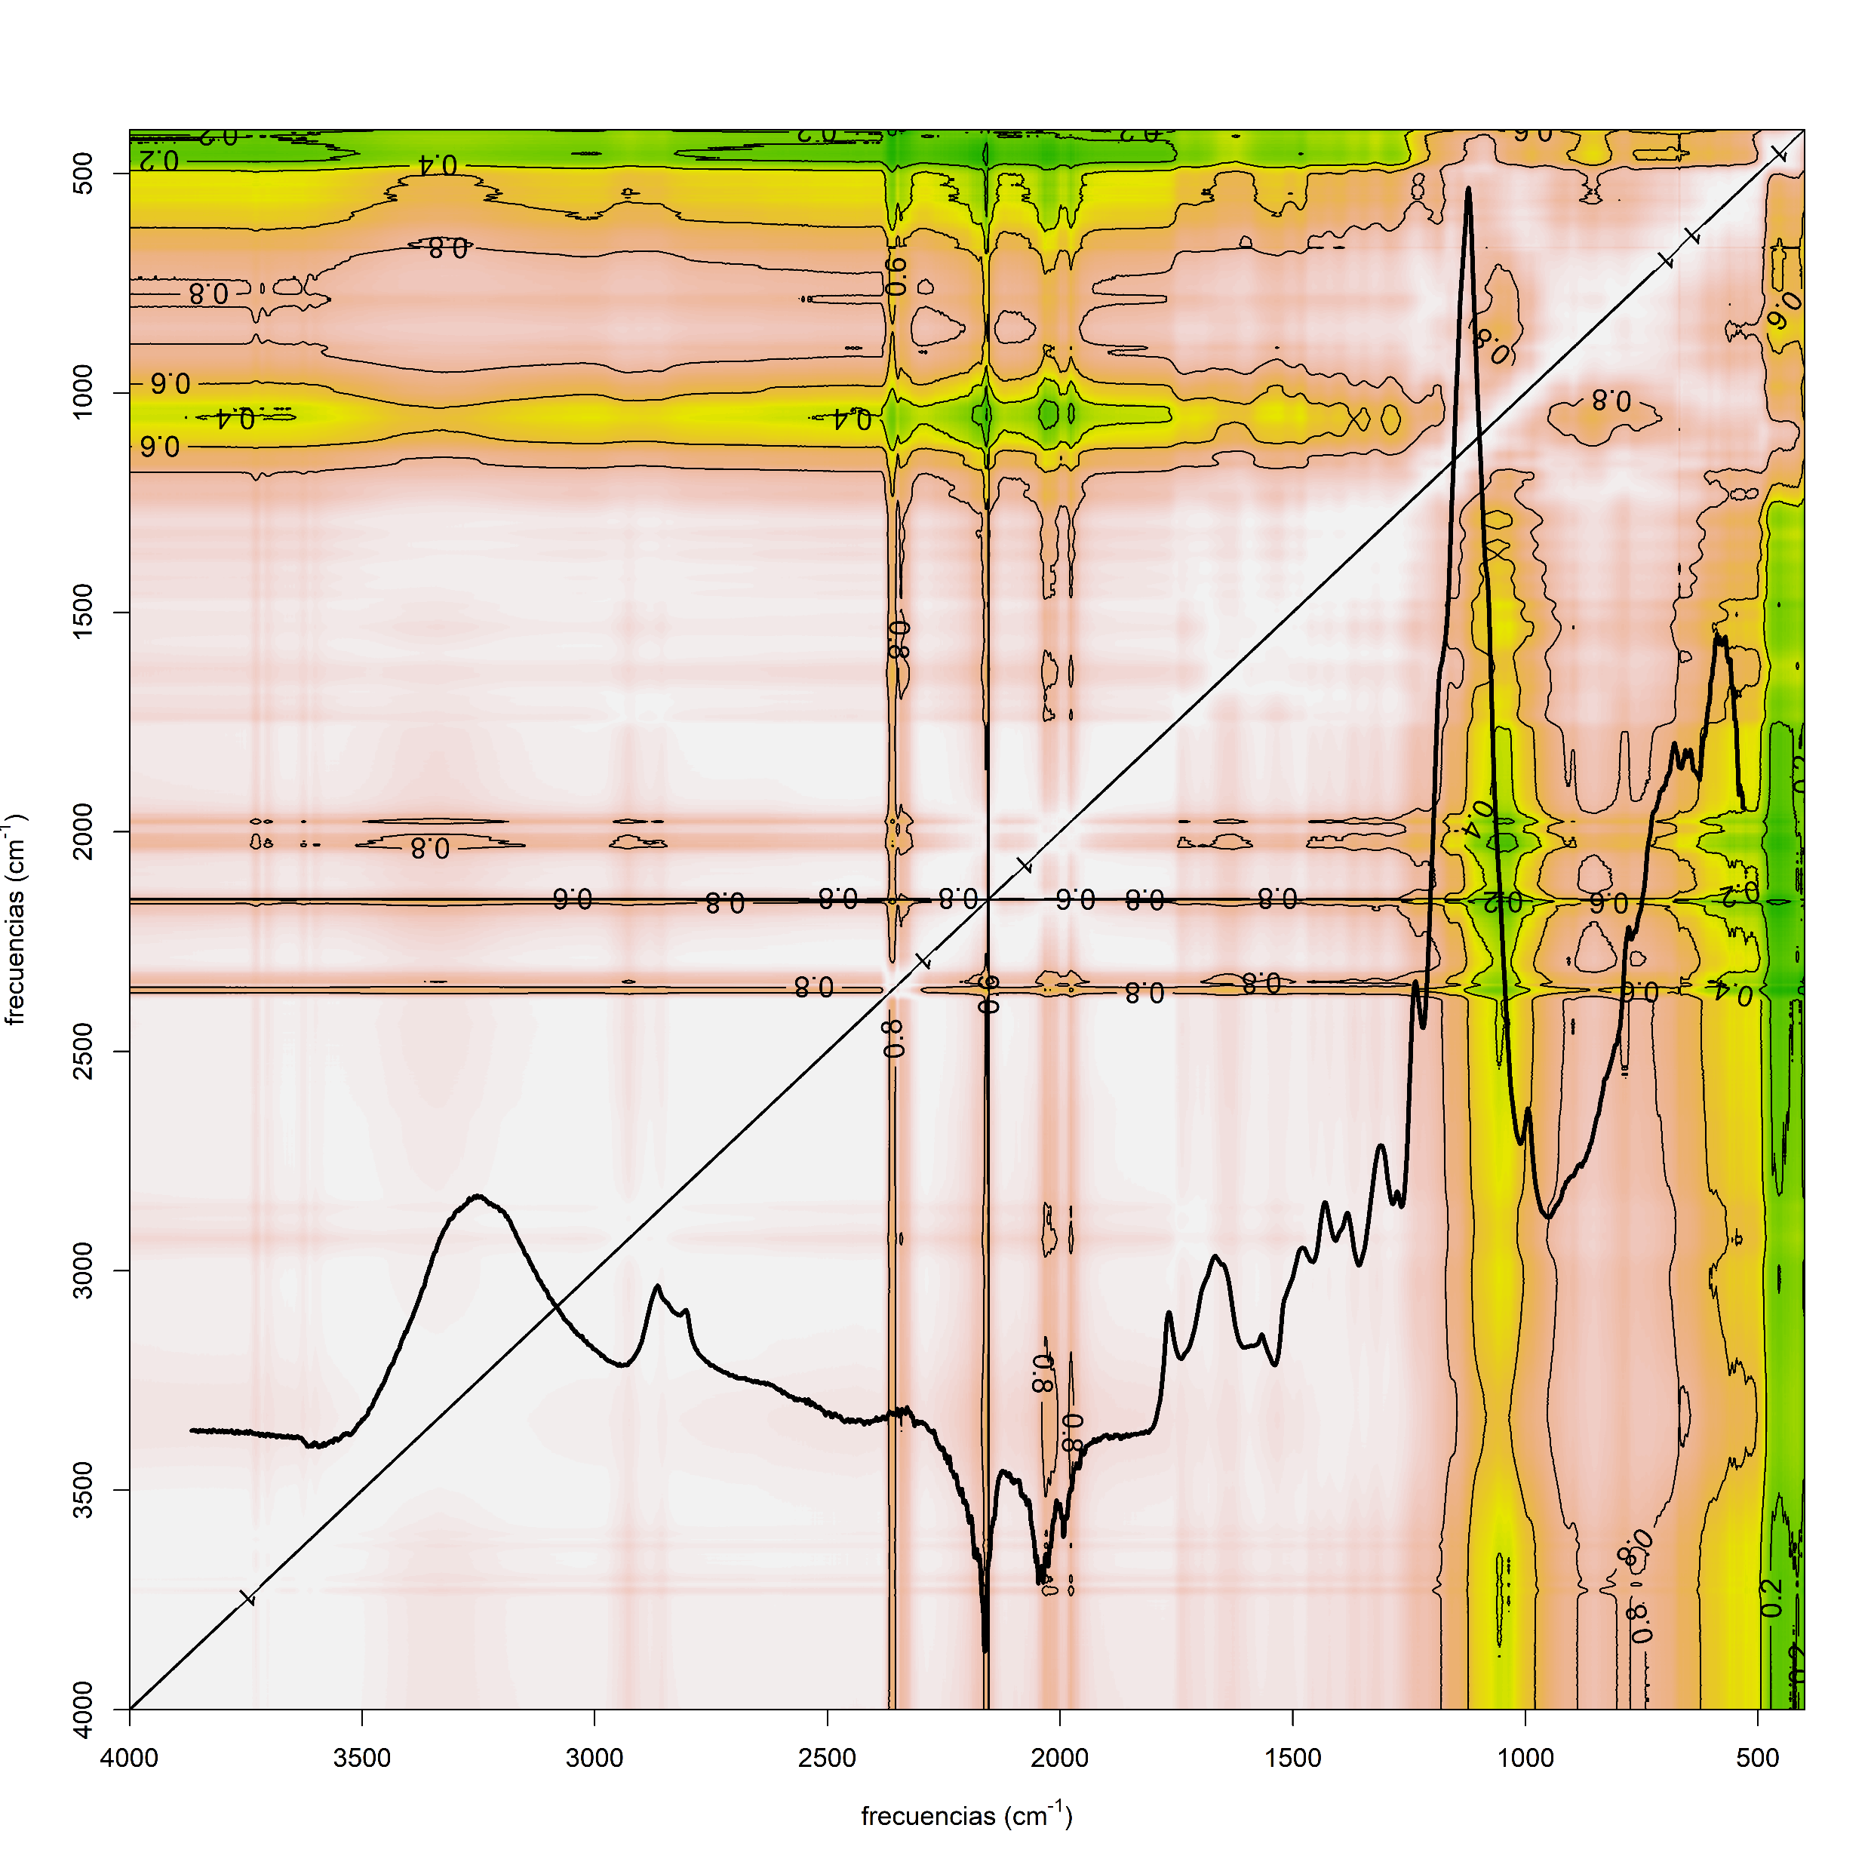**Results**

Puedes pegar las figuras des poster?

Estas sin la flecha amarilla.

Ess 2 sin el verde, y sin el café-



Figure #: Baseline correction procedure





References

Epstein, E., 1994. The anomaly of silicon in plant biology. Proc Natl Acad Sci USA 91. https://doi.org/10.1073/pnas.91.1.11

Głazowska, S., Murozuka, E., Persson, D.P., Castro, P.H., Schjoerring, J.K., 2018. Silicon affects seed development and leaf macrohair formation in Brachypodium distachyon. Physiologia Plantarum 163, 231–246. https://doi.org/10.1111/ppl.12675

Kumar, S., Soukup, M., Elbaum, R., 2017. Silicification in Grasses: Variation between Different Cell Types. Frontiers in Plant Science 8, 438. https://doi.org/10.3389/fpls.2017.00438

Laursen, K.H., Hansen, T.H., Persson, D.P., Schjoerring, J.K., Husted, S., 2009. Multi-elemental fingerprinting of plant tissue by semi-quantitative ICP-MS and chemometrics. J. Anal. At. Spectrom. 24, 1198–1207. https://doi.org/10.1039/b901960j

Mansfield, S.D., Kim, H., Lu, F., Ralph, J., 2012. Whole plant cell wall characterization using solution-state 2D NMR. Nat. Protocols 7, 1579–1589. https://doi.org/10.1038/nprot.2012.064

Melucci, D., Zappi, A., Poggioli, F., Morozzi, P., Giglio, F., Tositti, L., 2019. ATR-FTIR Spectroscopy, a New Non-Destructive Approach for the Quantitative Determination of Biogenic Silica in Marine Sediments. Molecules 24, 3927. https://doi.org/10.3390/molecules24213927

Rafi, M.M., Epstein, E., 1999. Silicon absorption by wheat (Triticum aestivum L.). Plant and Soil 211, 223–230.

Vogel, H., Rosén, P., Wagner, B., Melles, M., Persson, P., 2008. Fourier transform infrared spectroscopy, a new cost-effective tool for quantitative analysis of biogeochemical properties in long sediment records. Journal of Paleolimnology 40, 689–702.

